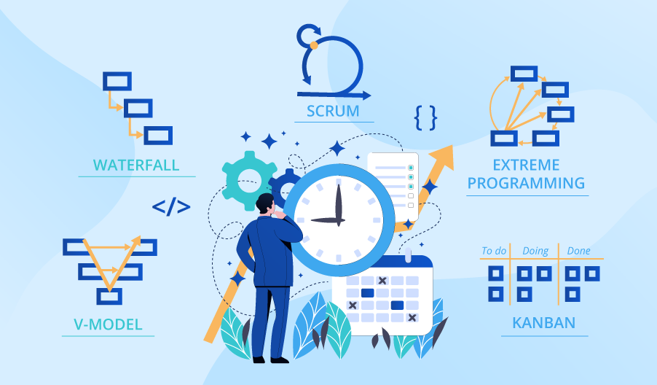

**SE423**

**Software Project Management**

**Activity**

**Activity 5. Schedule Negotiation Activity**

Review the article: [How to Defend an Unpopular Schedule](http://www.stevemcconnell.com/ieeesoftware/bp03.htm).

Read the case studies: Case Study: Giga Safe's ICS 1.0 and A Successful Schedule Negotiation.

As a team, answer the following discussion questions and submit to LMS.

**Questions:**

1. What was the first mistake made by Carl in his approach to estimating the time required for Giga-Safe's ICS 1.0?
2. How does Bill contribute to the problem?
3. In reality how late was the project (in months)?
4. List some alternative approaches Carl may have taken.
5. How does Tina's scheduling experience differ from that of Carl's Giga-Safe project?
6. What aspects of "principled negotiation" does Tina effectively use?
7. Use the web to find other, non-software examples of principled negotiation techniques. List at least two, including an explanation of why this is an example of such.

Be sure to include all group member's names in your submission.